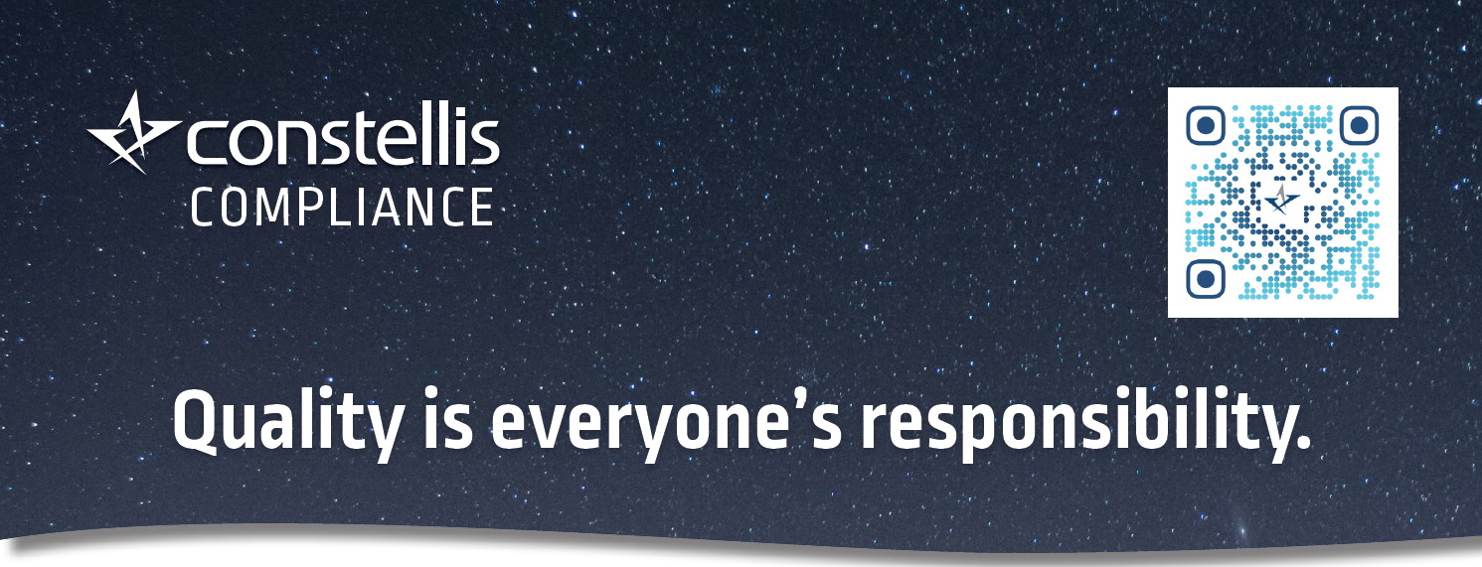

Constellis and its affiliates are committed to providing the highest quality of training, products and services, and to abiding by all applicable legal and standard- related requirements. We proactively take steps to avoid, prevent and reduce the likelihood of disruptive or undesirable events and their consequences. Respect for human rights, a commitment to safety, and caring for the environment are among our foremost priorities when conducting operations. We are dedicated to the continual improvement of our management systems, ensuring alignment with our corporate goals, and enhancing customer satisfaction. Version 2.1
For more information or to provide comments, contact Quality@Constellis.com.

